Nutrition Information
Servings Per Package: 4
Serving Size: 5 pcs. (50 g.) Liquid Excluded.

Typical Value Per 100 g

Energy 133 •cal – 556 •˜

Per Single Serving 20 g

2… •cal – 113 •˜
E A RA E ILLE IL

o o .:

Water, Milk Powders,Palm Olein,

Protien

Carbohydrate

of which Total Sugars Total Fat
2.™ g

12.5 g

5.2 g

™.0 g
0.6 g

2.5 g

1.0 g

1.6 g

E ED

FILLED

Milk
Maltodextrin, Emulsifier (Soy Lecithin (INS 322i)), Stabilizers (Disodium Phosphate
(INS 399ii)),Monosodium Phosphate (INS 339i), Carrageenan (INS 40…), Vitamin A & D3.
�����ا ��أو ،���� ���� ء،�� :ت�����،ا
�����ا ������) ������ ،�������د����� (INS ٢٢٣i))، م��د���ا ����� ت�����) ت�����ا (INS ٩٩٣ii))، م��د���ا ��د��أ ت�����
،)٧٠٤ (INS ا���را����ن ،i)٩٣٣ (INS ������. أ و د٣

ALLERGEN: Contains Milk & Soy Products.

of which Saturated Fat

Trans Fat

Monosaturated Fat

Polyunsaturated Fat

Cholestrol

Dietary Fibre› Total Sodium
3.5 g 0.… g

0.0 g 0.0 g

3.5 g 0.… g

1.0 g 0.2 g

0.0 mg 0.0 mg

0.™ g 0.2 g

60.2 mg 12.0 mg

Rich & Creamy
�����وا �����ا ت����� ��� ي���� �������ا ت�����.

PRODUCT OF MALAYSIA

•.r.: o o
E E EE T M OR E IR D TE

.: •    ­€ ‚ ƒ „ •
Shake well before use
.r •
For Comments & Inquiries, Please Call 04 25 02
Please E-mail contact@shanfmcg.com or visit www.shanfmcg.com
Owner of the Right Of Manufacture & Distributed By
han Internationa Genera Trading c

Calcium
156.0 mg 31.2 mg

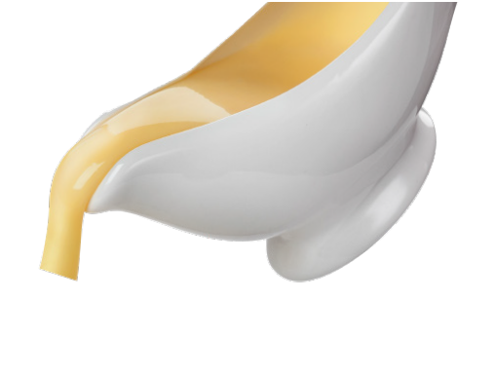
NET WEIGHT: 400 g
:

